**1.PROBLEM**

**CSS - Simple Menu (color, text-decoration - Hover)**

Pink Frag Event Organization is a company grown from strength to strength, entirely committed to a flexible, "hands on approach" – paying the closest attention to customer's needs and always providing a professional service in managing every sort of events. The Creative team of the company has announced a Tech-Contest to challenge millions of young talent on styling and web designing fields. Assume that you have registered for the contest being an aspiring web developer. The challenge you are given is to create a website for the organization using external styling methods. The website should contain many linked web pages where the styling can be applied on different activities like hovering, being active, visited links etc.,. Create a website with all the specifications to win the contest.

**Hints :**

**: hover selector**

The :hover selector is used to select elements when you mouse over them.

The :hover selector can be used on all elements, not only on links.

Syntax :

:hover {

css declarations;

}

**: active selector**

The :active selector is used to select and style the active link.

A link becomes active when you click on it.

Syntax :

:active {

css declarations;

}

**: visited selector**

The :visited selector is used to select visited links.

Syntax :

:visited {

css declarations;

}

**Content :**  
Create a table with two column with single row.  
First column will have only links as given below  
**Home  
Events  
About us  
Contact Us**  
Second column will have only the contents about the selected link.  
When **Home**link is clicked, the home page content should be displayed.  
When **Events** link is clicked, event page content should be displayed.  
When the link is hovered, color & background will gets changed.  
When it is clicked , it gets highlighted by some contrast color compared with other menu links.  
  
**Constraints :**  
Design the html page as given in the sample screenshot1.  
First 'a' tag id should be **'home1'.**  
Second 'a' tag id should be '**events'.**  
Third 'a' tag id should be**'aboutus'.**  
Forth 'a' tag id should be**'contactus'.**  
  
 'a' tag should have the following style property  
 background color - **'#00CED1'**  
 color - **'#000000'**  
 width - **'100px'**  
 border - **'1px solid #000000'**  
 padding - **'15px'**  
 textalign - **'center'**  
 textdecoration - **'none'**  
 display - **'inline-block'**  
  
'a' tag should have the following style property while hover  
backgroundcolor - **'#4CAF50'**  
color - **'#FFFFFF'**  
width - **'100px'**  
border - **'1px solid #000000'**  
padding - **'15px'**  
text align - **'center'**  
text decoration - **'none'**  
  
'a' tag should have the following style property while active  
background color - **'#F0E68C'**  
width - **'100px'**  
border - **'1px solid #000000'**  
color - '**#FF8C00'**  
padding - **'15px'**  
text align - **'center'**  
text decoration - **'none'**  
  
**Note :**  
Web page should be displayed as shown in the screenshot.  
Kindly refer the content which is given as a part of the description.

**Sample Screenshot 1:**  
  
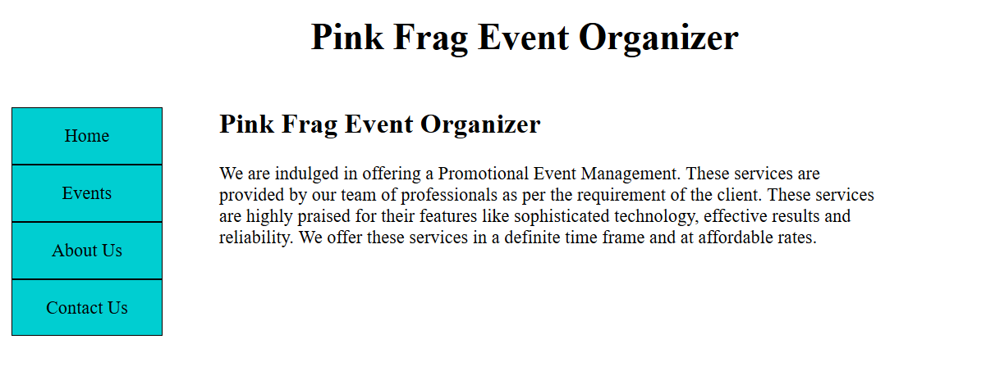  
  
**Sample Screenshot 2:**  
  
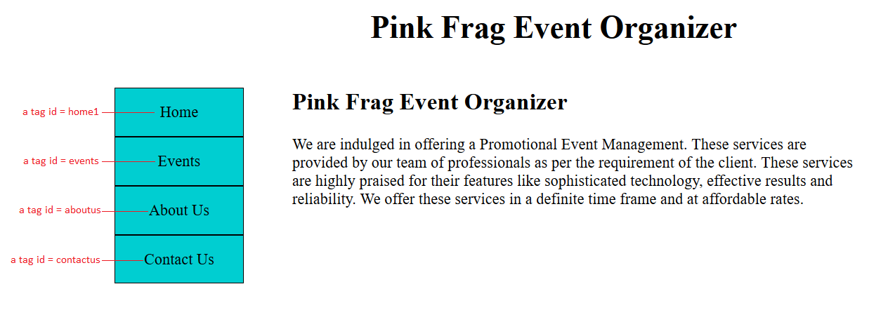  
  
**Sample Screenshot 3:**  
While hovering an 'a' tag, the background color and color property should be changed as follows  
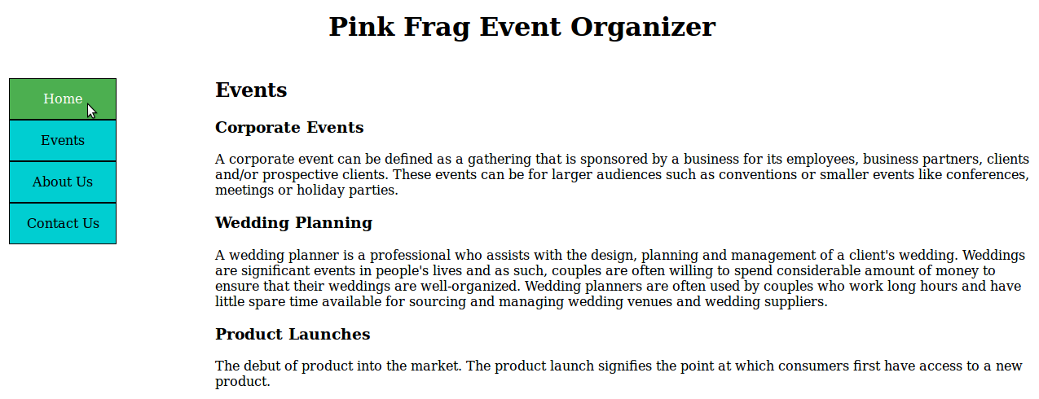  
  
**Sample Screenshot 4:**  
  
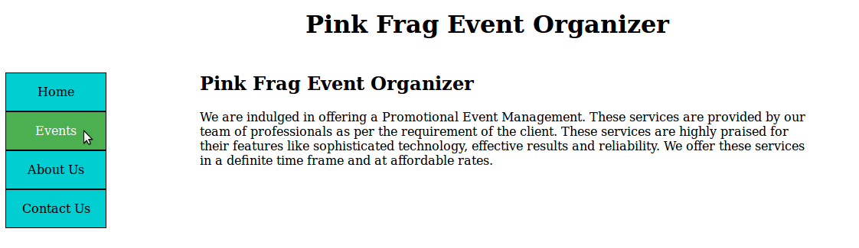  
  
**Sample Screenshot 5:**

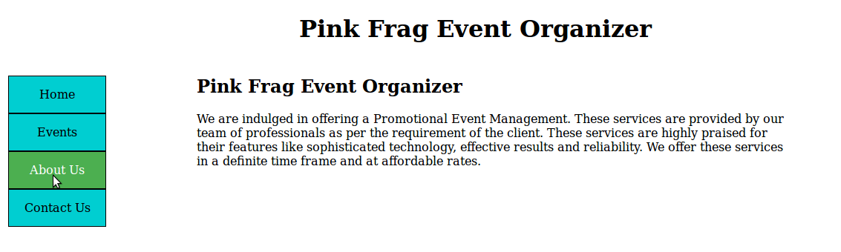

**Sample Screenshot 6:  
  
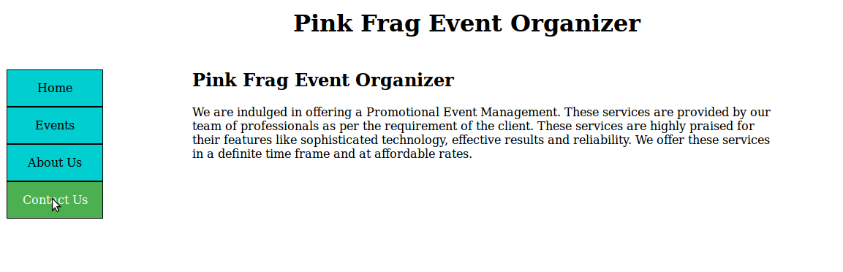  
  
Sample Screenshot 7:**  
When the 'a' tag is active, the background color and color should be changed as follows  
**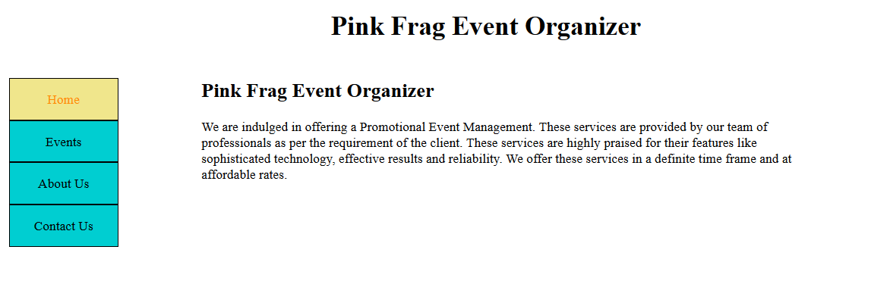  
  
Sample Screenshot 8:  
  
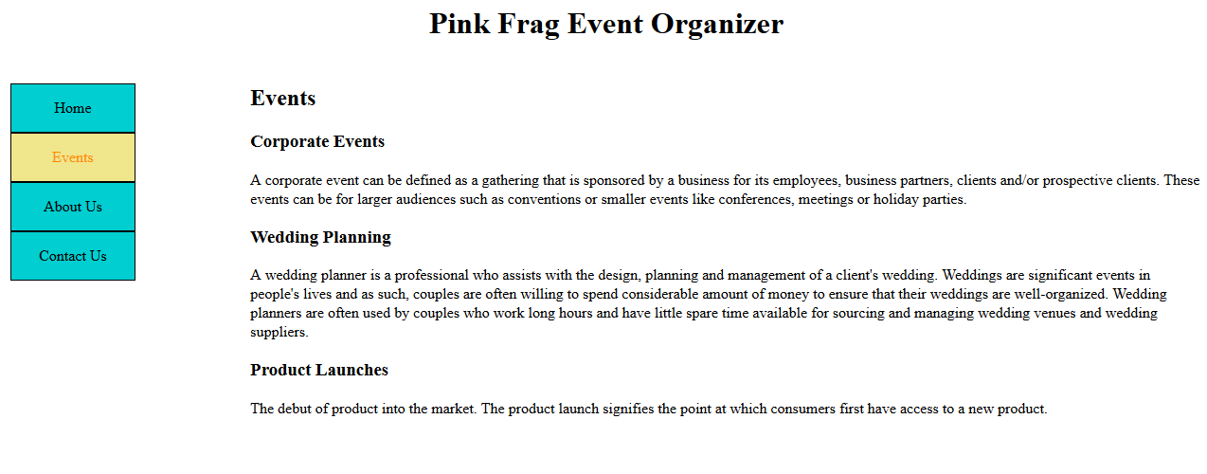  
  
Sample Screenshot 9:  
  
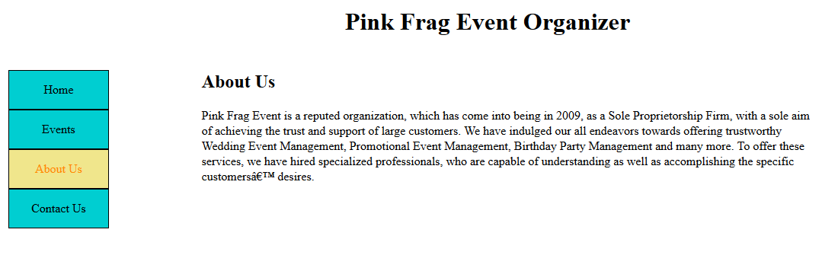**

**Sample Screenshot 10:  
  
